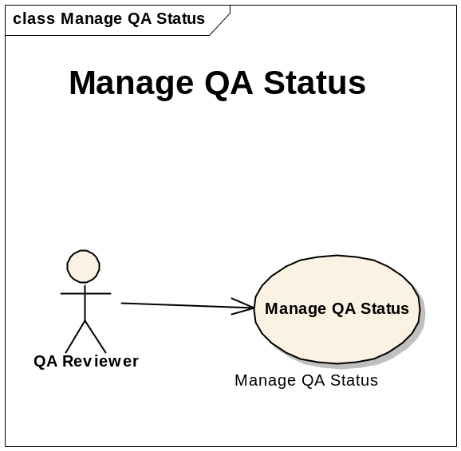

Manage QA Status

Brief Description
Images and annotation files submitted to NCIA go through a quality assurance process. This process ensures that the images are of high quality, are relevant and useful to researchers, and do not contain private health information. The QC Tool described in this use case allows the QA Reviewer to examine submitted images and annotation files and change their QA status as needed.

Primary Actor
QA Reviewer

Secondary Actors
NCIA Software

Preconditions

Precondition 1 – QA SOP Created
A NCIA image QA Standard Operating Procedure (SOP) for DICOM images has been developed in collaboration with the Cancer Imaging Program (CIP) and approved by National Cancer Institute Center for Bioinformatics (NCICB) and CIP.

Precondition 2 – Images Submitted
Images and/or annotation files have been submitted to NCIA and are ready for review by a QA Reviewer.

Precondition 3 – Security Rights
QA Reviewer has been granted the MANAGE_VISIBILITY_STATUS role for at least one protection element representing a collection, site or series security group.

Basic Flow of Events
- QA Reviewer navigates to Manage QA Status page by clicking the QC Tool link.
- QA Reviewer is presented with a list of all QA statuses
- QA Reviewer clicks on a status:
a. Not Yet Reviewed
b. Reviewed
1. Not Visible
2. Visible
- A QA Status may be assigned and applied to the status level for Patient, Study, Series, and Image.
- QA Reviewer may navigate to each status level to view a list of all collections that have images in that status.
- Collection --- A list of Patients
- Patients ---- A list of Studies
- Studies ---- A list of image Series
- Series ------ A list of Images
- The Collection is highlighted when the status of at least one on any level is changed during this HTTP session.
- QA Reviewer clicks on a collection
- QA Reviewer is presented with a list of all patients at each status level in the collection that have images.
- QA Reviewer has the option to change the QA status of images for one or more patients, studies, series, and/or images in the collection.
- QA Reviewer is presented with a list of annotation files for the series and a thumbnail for each image in the series.
- For each image, at the image level, the QA Reviewer has the option to:
- View a JPEG of the image
  - QA Reviewer clicks the “View JPEG” link for an image thumbnail.
  - A new browser window opens that displays a JPEG of the DICOM image.
  - QA Reviewer examines the JPEG to determine if the image and its data pass the standards established in the SOP.
  - QA Reviewer closes the second browser window.
- View the history for the image
- QA Reviewer clicks the “Show History” link for an image thumbnail.
- The history related to QA is displayed for this image in a new browser window. The history includes the following:
- Date of submission
- Dates of all status changes and what the status was changed to
- Comments provided by QA Reviewer when status was changed

- View DICOM header of the image
  - QA Reviewer clicks the “View DICOM Header” link for an image thumbnail.
  - A new browser window opens that shows all non-empty DICOM tags in the image’s DICOM header.
  - QA Reviewer examines the DICOM header values to determine if the image and its data pass the standards established in the SOP.
  - QA Reviewer closes the second browser window.

- Set the number of rows and columns for displaying the images.
- The default number of thumbnails display per row should be 5.
- The default number of thumbnails displayed per column should be 5.
- The order of compliance of displaying thumbnails are columns and then rows.

Alternate Courses

Alternate Course 1 – Alternative Flow 1 – QA Status Changed
NCIA Software determines the QA status from which the QA Reviewer navigated to get to the study. Images in the selected series with that status to which the QA Reviewer has access (MANAGE_VISBILITY_STATUS role) are changed to the newly selected status.

1.1.6.2 Alternative Flow 2 – QA Status History Saved
For each image, a Curation Status record is added to the database that includes associations to the image, the QA Reviewer that made the change and any comment provided. For each series, the series is assigned to the series security group (if provided).

1.1.6.3 Alternative Flow 3 – Visibility Flags Updated
NCIA Software verifies that the visibility flags of the series, its study and its patient are correct. The visibility flag at each level is set to true if at least one image under that item is set to a QA status of Visible.

1.1.6.4 Alternative Flow 4 – Confirmation Message
QA Reviewer is presented with a message indicating that the change was successful: “Status changed to {0}” where {0} represents the new status.

Exceptions

During the time period starting when the QA Reviewer loaded data for the image and ending when the QA Reviewer made the status change, another QA Reviewer has made a QA status change for the same image. Status change for that image is not saved and the following error message is displayed: “Could not change status of the image with SOP instance UID {0} because another user has made a status change to the same image.” where {0} represents the SOP instance UID of the image.

Postconditions

Postcondition 1 – QA Process Complete
QA Reviewer has evaluated all relevant images and changed their status as needed.

Special Requirements
Not Applicable

Data

QA statuses: | Status Levels | Update Permission
Not Yet Reviewed | Patients | Manage_Visibility_Status
Visible | Studies
Not Visible | Series
Resend | Images
Send to Curation | Site

